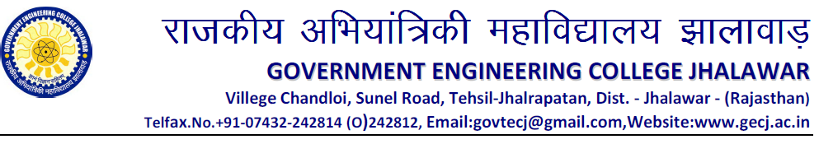
Computer Science and Engineering Department
Date: 09 /04 /2014
Notice

All the B Tech VIII Semester CSE students are hereby informed that the report (2 hard copy) of Seminar & IT Act Seminar is to be submitted latest by 25 April, 2014.

Note:-
Before printing of the report it should be checked by supervisor and supervisor can be of your own interest.

Head of CSE

